STRIVE
Huia Range School
Cole Street Phone 06 374 6444
Dannevirke 027 781 2224
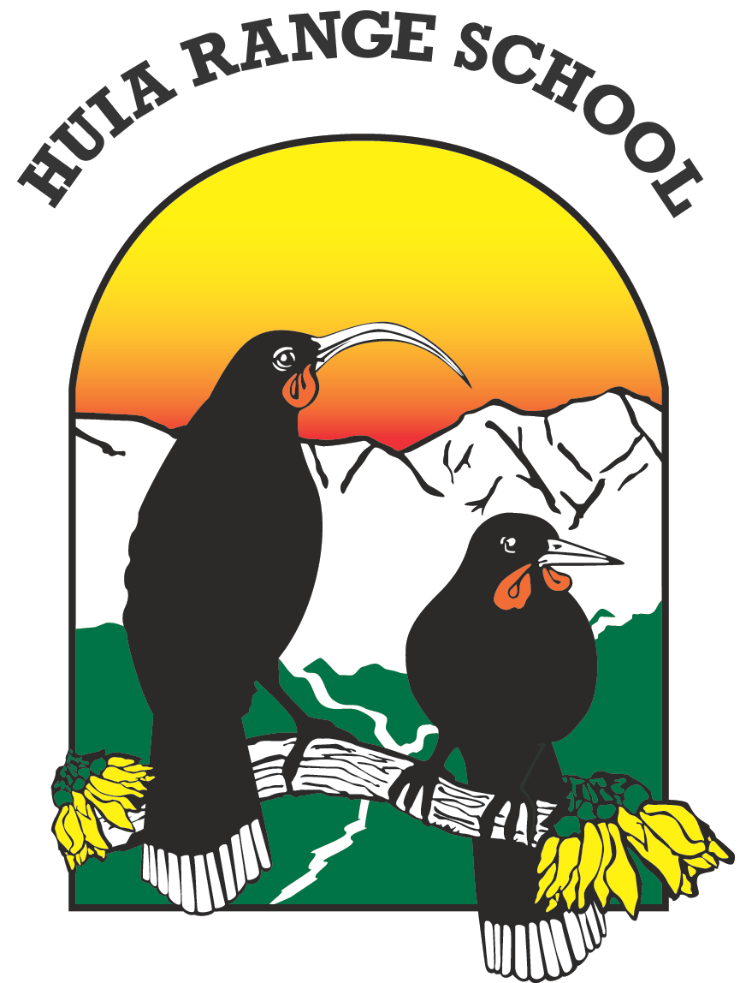
7th September 2021

Tēnā koutou katoa

Alert Level 2

School is reopening on Thursday 9th September, under Alert Level 2. At this level schools are open to everyone; it is safe for children and staff to attend school as there will be appropriate health and safety measures in place. Distance learning will continue to be available for students who required to self-isolate or those who need to remain at home because they are vulnerable to illness. It will be great to see all the students and staff back at school again.

Students must follow the health and safety measures we will have in place:
- Wash hands frequently with soap and water, and dry hands afterwards
- Cough and sneeze into elbows
- Use hand sanitizer regularly, including when you leave from and arrive in any room
- Children who are unwell must stay home, they will be sent home if they are sick when they come to school
- Children must have their own food container and drink bottle and not share food
- Keep your distance from other people and stay in the same bubble
- Follow the classroom and school behaviour expectations
- No games or toys are to be brought to school (including soft toys)

Dropping your child at school
Drop your child at school at the main Cole Street entrance between 8:30am and 8:55am. Staff have been asked not to park on the school side of Cole Street, so parents will be able to quickly and easily drop off and pick up children.

Visitors and Parents
Only 10 visitors are allowed at school at any one time, because of this no parents may come into the school without first contacting the office on 06 374 644 or 027 781 2224. The main office will be locked at 9am, if you want to bring anything into school for your child please phone the office and arrange to drop off the item outside the main door,

Leaving school
We will be operating staggered release times in the afternoon. At 2:45pm students from rooms 15, 5, 6, 7 and 8 will be walked to the main entrance on Cole Street, with their older siblings. Teachers will stay with them until they are collected. All other students will be leaving between 2:50 and 3:10, teachers will inform you through Class Dojo of the time their class will be released at the end of the day.

Food and drink bottles
School lunches will continue to be provided. Children will need to bring on morning tea on Thursday and Friday because Fruit in Schools will not be in place this week. Children must also bring a drink bottle everyday as the drinking fountains should not be used.

Masks
The Ministry of Health has strongly recommended that masks are warn by students over 12 years old. Younger students can wear masks, but it is important that these younger children can safely take their masks off and put them on without assistance, and wear them correctly.

Break time and lunch time
Classes will be operating in small groups at morning tea and lunch time. Different groups will be using different areas of the playground and be out of class at different times.
The school adventure playgrounds will be spray disinfected every morning and children can only play on them if they have sanitized their hand before play and again as soon as they return to class.

Returning iPads
Students who have been issued with a school ipad and charger needed to bring these back on Thursday as they will need them for their learning.

School and Interschool Activities
The interschool events (math competition, speech competition, aerobics festival) have all been cancelled, as has the Kapa Haka Festival. THE TEACHER ONLY DAY PLANNED FOR FRIDAY HAS BEEN CANCELLED FOR THIS TERM.

If you need any information, please phone the school office.

Noho ora mai
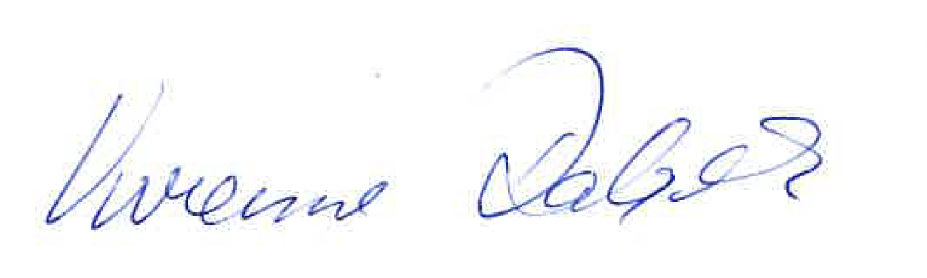
Vivienne Dalgleish Acting Principal

