STRIVE

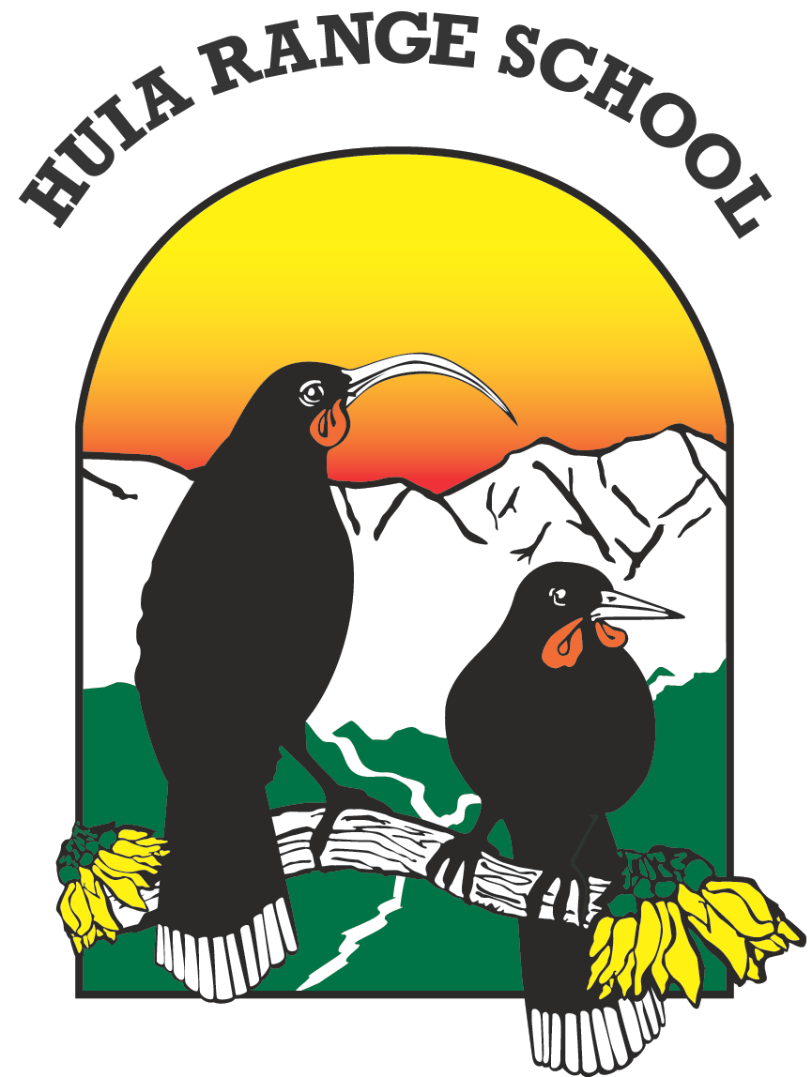
30 August 2021

Alert Level 3 Planning

Under Alert Level 3, schools can open for children of people who qualify as essential and safe business workers only. The Government's message remains the same:

STAY AT HOME IN YOUR BUBBLE. IF YOU ARE WORKING FROM HOME, OR AREN’T WORKING, KEEP YOUR CHILDREN AT HOME.

We open at school on Wednesday under Covid Level 3 a few returning children and five staff. The students will be working in two bubbles (two classrooms) and we will be operating with strict enforcement of health and safety measures.

Distance learning will continue for all the children who are not at school. Staff who are not at school will support distance learning either online or though work packs and Class Dojo.

If you need any information, please phone the school office from Wednesday—do not come into the office.

Ngā mihi
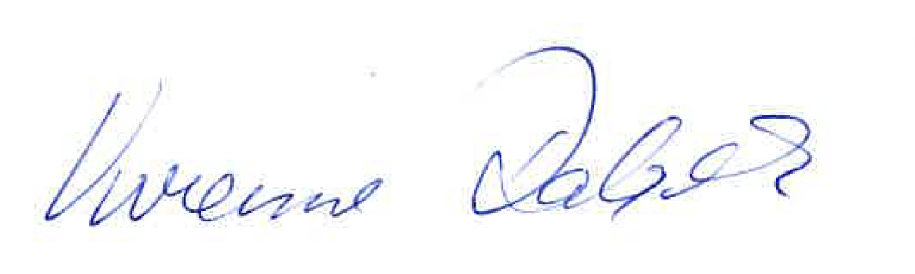
Vivienne Dalgleish Acting Principal

Huia Range School
Cole Street Phone 06 374 6444
Dannevirke 027 781 2224

